Pineapple Game IDE 1.0
Pineapple archive file format
Last Updated: July 17. 2009

Overview
Pineapple archives(with the “.pba” file extension) are files specifically designed to store PineDL bytecode. They don't contain the exact code, they contain the compiled version of code.

Storing Data
Each Pineapple Archive requires storing multiple kinds of data. The following data kinds of data are used:

- Unsigned byte: A single byte. Stored as 1 character in the filesystem
- Unsigned Integer 16-bit: 2 bytes(2 characters in the filesystem). Stored in low-endian
- Unsigned Integer 24-bit: 3 bytes(3 characters in the filesystem). Stored in low-endian
- Unsigned Integer 32-bit: 4 bytes(4 characters in the filesystem). Stored in low-endian
- String: Contains an unsigned integer of 32-bits with the string length, and then the string content itself.
- Fixed-length string of length X: Contains X characters with the string content. The string itself may have up to X characters, but some of them may be '\0'.

Structure Of A Pineapple Archive
Every single Pineapple archive has the following structure:

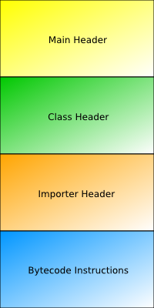

The Main Header
The main header contains the following data:

- The exact characters “pba”(3 bytes, ASCII)
- An unsigned integer of 16-bit containing the archive version. It must be 1.
- An unsigned byte containing the type of the archive. See the section “Archive Types”.
- The numeric list. See the section “Numeric List”.
- The string list. See the section “String List”.
- The string array list. See the section “String List”.

Archive Types
The following archive types are allowed:

- Executable – Identified by the number 0
- Static Library – Identified by the number 1

Numeric List
The numeric list contains information that is kept as numbers.
First, comes an unsigned integer(16-bit) with the number of elements the list has.
Then, for each list element, the file has the following:

- A fixed-length string of length 10 with the “element key”. For example, Pineapple uses “win-width\0” to identify the initial game window width.
- An unsigned integer (16-bit) with the element value.

String List
The string list contains information that is stored in strings.
First, comes an unsigned integer(16-bit) with the number of elements the list has.
Then, for each list element, the file has the following:

- The “element key”(a string). All elements with the key prefix “info-” may be removed when creating an executable. However, this behavior is compiler-dependent.
- The “element value”(another string)

String Array List
The string array list works as a list of lists.
First, comes an unsigned integer(16-bit) with the number of elements the list has.
Then, for each list element, the file has the following:

- The “element key”(a string). All elements with the key prefix “info-” may be removed when creating an executable. However, this behavior is compiler-dependent.
- The number of strings stored in the element's content(an unsigned 16-bit integer).
- Strings(as many as specified by “number of strings in element's content”)

